Project Data Visualization Report

This document contains visual insights from the Promo Code Abuse Detection project. Various data visualization techniques were applied to explore user behavior patterns, promo usage frequency, and fraud detection results.

# Promo Code Usage Distribution

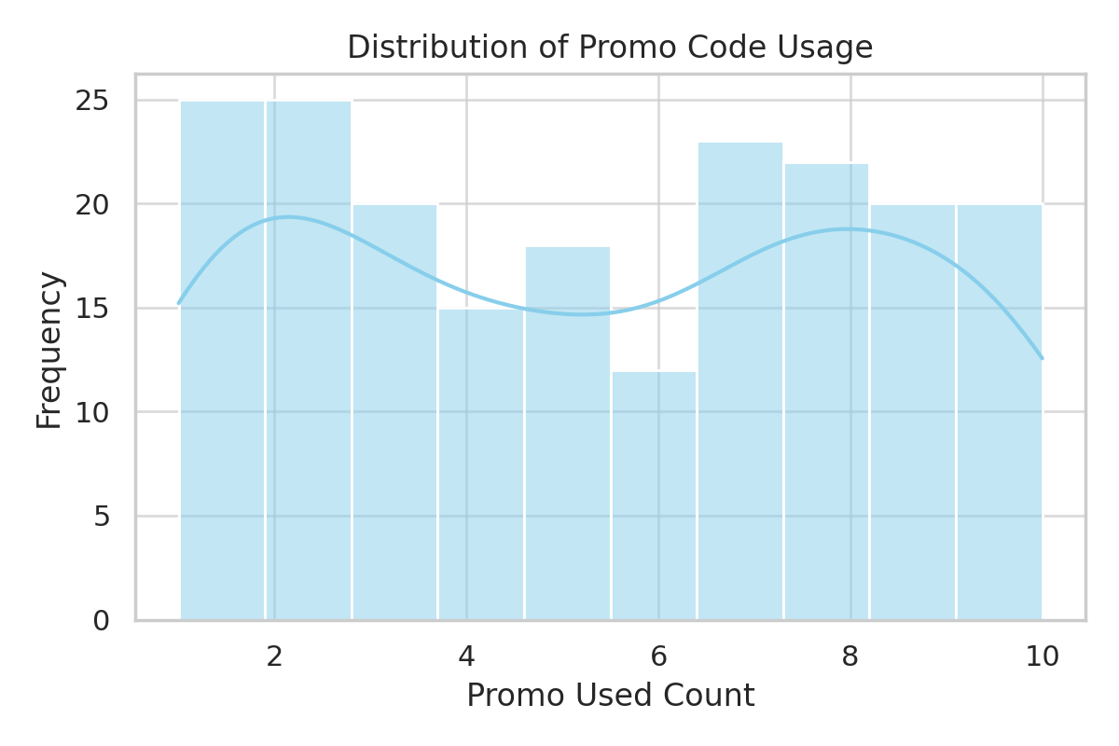

# IP Count Frequency Distribution

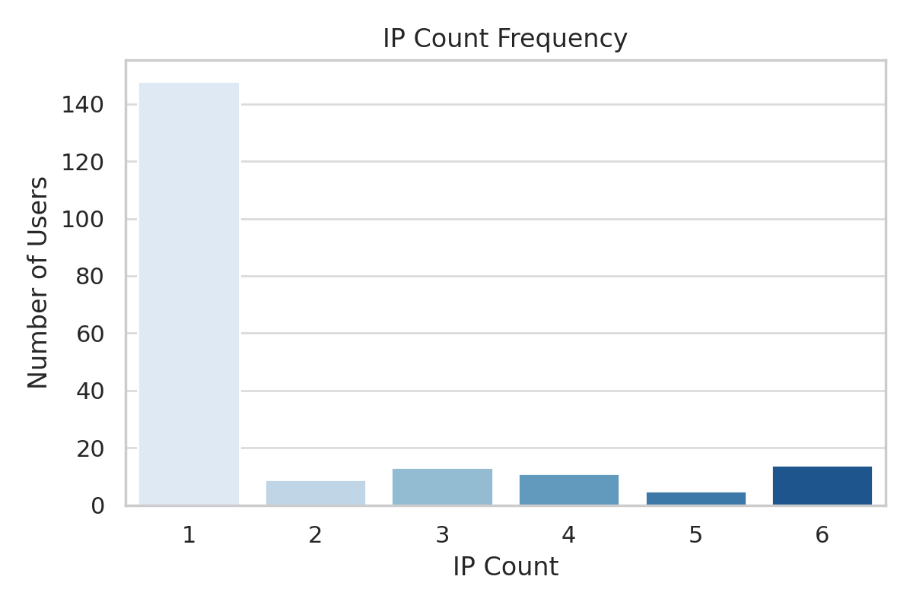

# Fraudulent vs Non-Fraudulent Users (Pie Chart)

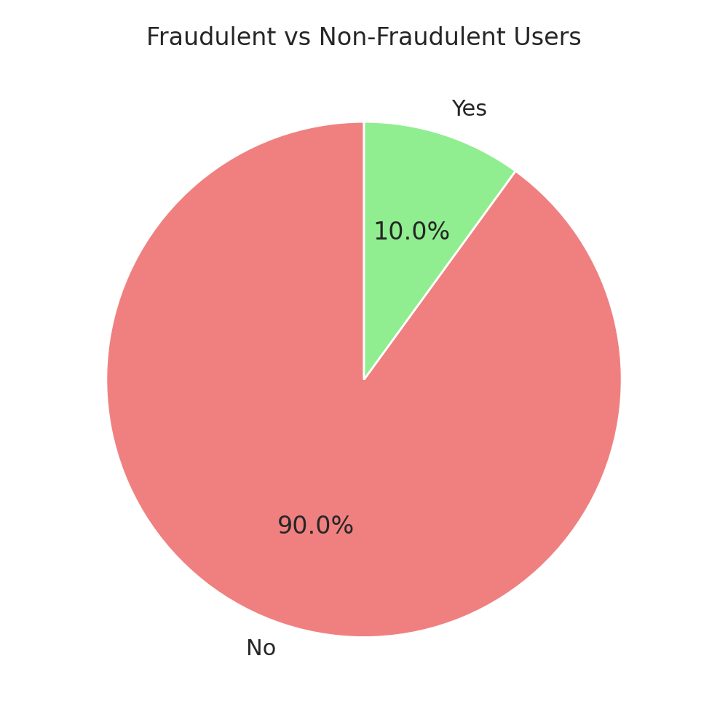

# Heatmap: Promo Used vs IP Count

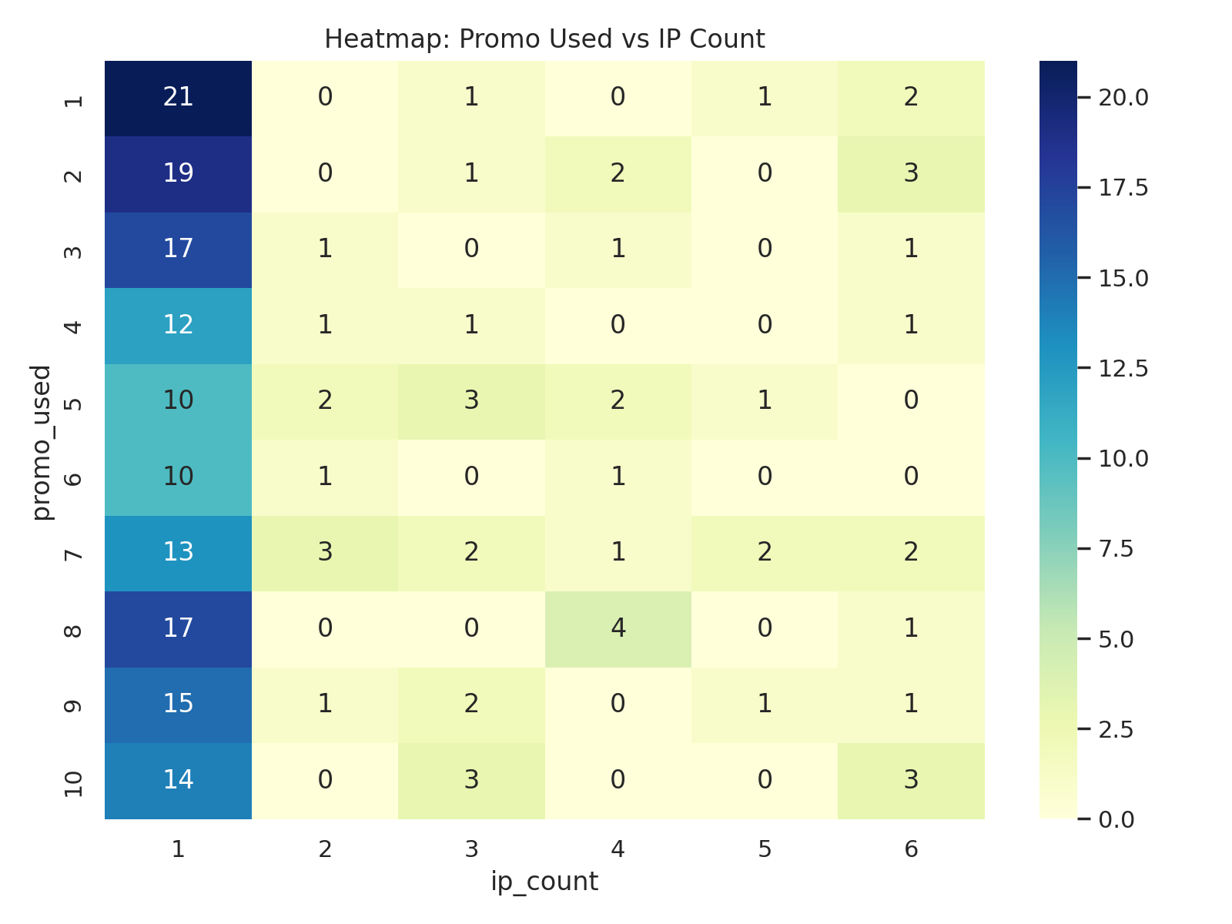

# Fraud Score Distribution (-1 = Fraud, 1 = Legit)

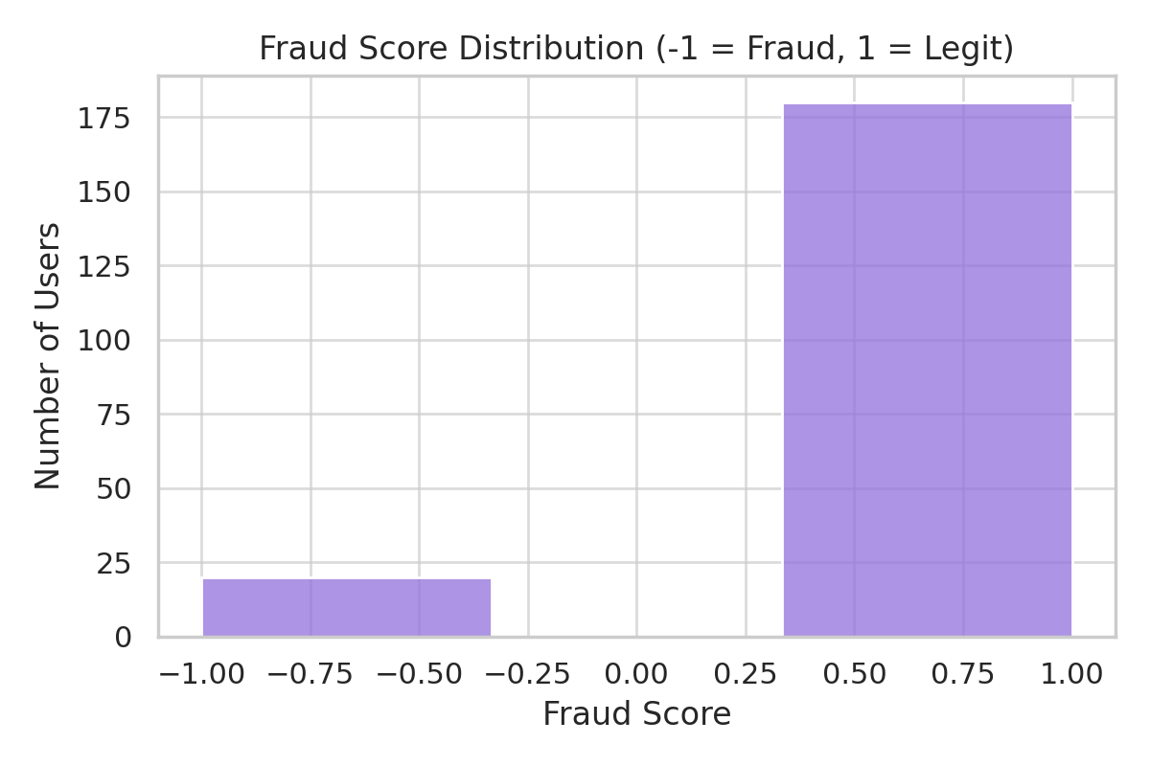

# Team Members

- M.M.S. Chandra Nagu – ML Engineering  
- A. Subash – Dataset & Backend  
- G. Nikitha Chowdary – UI, Testing & Report